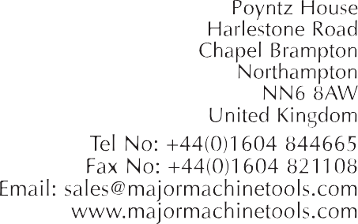

PO No 3726
WEBSTER & BENNETT 120” DCH Double Column Vertical Turning and Boring Machine
Serial Number 5971-1R
Max Swing 122” 3100 mm
Max height under cross rail 78” 1981 mm
Max table load 25 tons
Ram slide vertical travel 48” 1220 mm
Turret slide vertical travel 38” 965 mm
Table speeds (12) 1.5 to 39.5 rpm
Feed rates (12) .05 to 2.5 mm/rev
With Timken bearing table,
Power Turret,
Newall DP700 two axis digital readout
Hardened slide ways
Pendant control
Interlocking guards
Coolant.
NB.The above information has been obtained with care to the best of our ability. It is given in good faith, but its accuracy cannot be guaranteed.
Accordingly, it does not form a representation or constitute a contractual term.
Prospective purchasers are advised to check any vital details.
Complete Health and Safety Act, April 1st 1974:
It is not reasonably practical for ourselves as suppliers to ensure that for your application the goods comply with the requirements of the act with respect to guarding etc.
We would like to remind prospective purchasers to ensure that a guarding specialist or their own health and safety officers inspect the goods prior to use.

